Robb, Ian (from Tree Crop Technologies website)
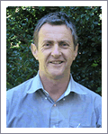
B Sc Forestry ANU 1977.
Has 30 years of experience in plantation and native forest management. He has worked across tropical, subtropical and dryland forest types, and has a comprehensive technical knowledge of forest management, particularly commercial plantation forestry, plantation based bio-fuel, carbon sequestration, and land management legislation.
Prior to joining TCT, Ian was General Manager Hoop Pine with Forestry Plantations Queensland. In 1999, was General Manager Hardwoods.

General Manager Forestry & Cropping Tree Crop Technologies Pty Ltd July 2008 – , Brisbane Area.

